Place Plans

Autumn 24

What is a Place Plan?

[](https://www.conwy.gov.uk/en/Resident/Planning-Building-Control-and-Conservation/Place-Plans/Place-Plans.aspx)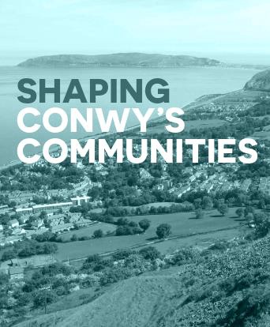Place Plans are a way to address land use and   
development issues and concerns at the local, community   
level, as well as to achieve local aspirations.

Place Plans add local level detail to Local Development Plans and can be adopted by the Local Authority as Supplementary Planning Guidance (SPG).

In order for a Place Plan to become SPG, the community preparing the Place Plan will need to ensure it is prepared with the input of the Local Authority. It will also need a

strong evidence base and a good level of community   
involvement. [Place Plans - Conwy County Borough Council](https://www.conwy.gov.uk/en/Resident/Planning-Building-Control-and-Conservation/Place-Plans/Place-Plans.aspx)

**Who can prepare Place Plans?**

Place Plans are prepared by Town and Community Councils.

It is also crucial that you work closely with us at CCBC as we can give your eventual plan some status, maybe even legal status. It will be important that your Place Plan fits together with the Local Development Plan. If you go off and try to do a Place Plan on your own, it won’t have the influence you want! The   
involvement and support of the Local Authority Strategic Planning team will help you to produce a well   
evidenced plan

***The Benefits…***

• A way of establishing what the important development issues are in your community and agreeing

ways to address those in the future.

• Enables positive and proactive input into the local planning system, offering you more influence

over planning decisions.

• The evidence and information which underpins your Place Plan

can be used to secure funding for identified actions and projects.   
• A way of improving the working relationship between you and

your local authority (and possibly other service providers).

**Mae’r ddogfen hon ar gael yn Gymraeg hefyd**

**Recent News –**

*Place Plans - moving ahead*

The last 12 months have seen the Towyn & Kinmel Bay Place Plan become the first in Conwy to be adopted as SPG and in January the Bay of Colwyn saw the launch of their Place Plan covering the communities of Old Colwyn through to Rhos-on-Sea.   
More recently The Bay of Colwyn have completed Phase 2 ‘Plan to Action’ where they [](https://www.colwynplaceplan.com/video)have created working groups focusing on the 6 themes identified in their plan.

Towyn & Kinmel Bay are currently looking to recruit new board members and review their Terms of Reference whilst Abergele have recently appointed a new Project   
Management and Funding Officer to facilitate the Placeplan with funding secured for another year. The Bay of Colwyn have also successfully secured recent funding to appoint their own Place Plan Manager.

In June we saw the very first meeting of the Conwy Place Plan network where all 3 Place Plan committee representatives came together to discuss lessons learnt and   
future processes.

*Place Plan or Community Plan?*

Last year our colleagues in the Economy & Culture team introduced a Place Plan KickStarter programme designed to assist communities who were considering   
embarking on creating a Place.

Supported by Planning Aid Wales (PAW) Llanfairfechan, Penmaenmawr, Llanrwst and Conwy Town Councils were supported in bringing communities and Town Councils   
together to explore the possibility of developing Place Plans in their area.

This exercise involved consultation on important issues in the community, whether   
there were any gaps in provision and what priorities could be identified.

Importantly communities considered which approach best met the needs of these communities and whether a Place Plans was the appropriate way forward.

We have also taken a pro-active approach in the areas around the 4 Strategic Site identified in the RLDP to promote site based Place Plans as a potential approach to support these areas going forward.

For more information please visit: [Conwy Community Guides (placeplans.org.uk)](https://www.placeplans.org.uk/conwyguides/) For more general information please visit: [Introducing Place Plans – Place Plans](https://www.placeplans.org.uk/en/?page_id=315)   
**If you would like to discuss Place Plans in Conwy and how they may be**

**able to assist your community please contact** [placeplans@conwy.gov.uk](mailto:placeplans@conwy.gov.uk)

**For more**   
**information on**   
**Abergele, Towyn & Kinmel Bay or the Bay of Colwyn**

[Abergele | Abergele Place Plan (abergelepensarn.co.uk)](https://abergelepensarn.co.uk/we-love/future)

[Welcome | TKBVOICE | Towyn & Kinmel Bay](https://www.tkbvoice.wales/)

[Colwyn Place Plan | Community | Conwy](https://www.colwynplaceplan.com/) [Video | Colwyn bay (colwynplaceplan.com)](https://www.colwynplaceplan.com/video)